Book

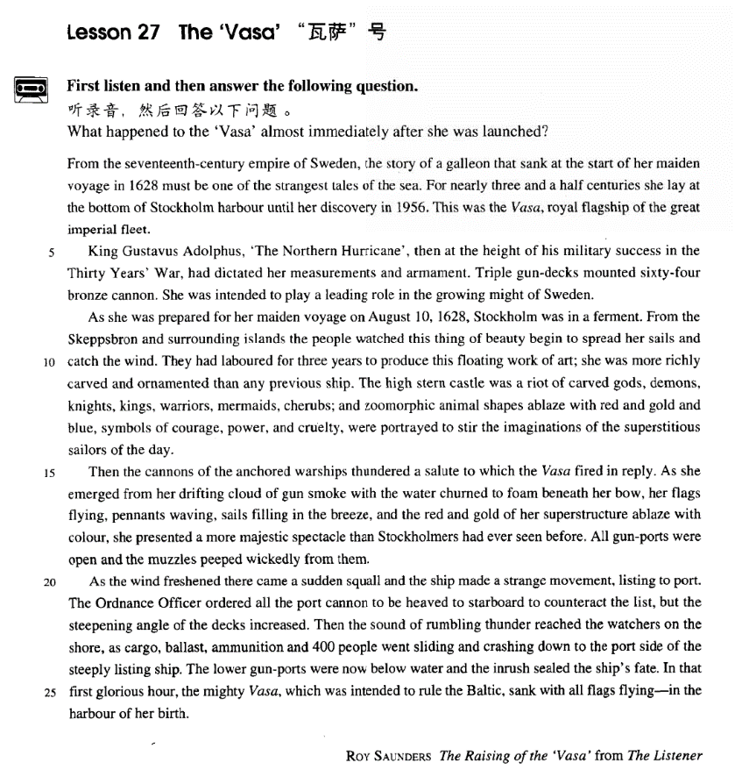

课文

From the 17th-century empire of Sweden, the story of a galleon that sank at the start of her maiden voyage in 1628 must be one of the strangest tales of the sea.

1628年，一艘大帆船在处女航时就沉没了，这个从容不迫7世纪瑞典帝国流传至今的故事无疑是航海史上最离奇的事件之一。

For nearly 3.5 centuries she lay at the bottom of Stockholm harbour until her discovery in 1956.

这艘大船在斯德哥尔摩港口的海底躺了将近几年来个世纪之后，直到1956年才被发现。

This was the Vasa, royal flagship of the great imperial fleet.

这就是“瓦萨”号，帝国大舰的皇家旗舰。

King Gustavus Adolphus 'The Northern Hurricane', then at the height of his military success in the 'Thirty Years' War, had dictated her measurements and armament.

当时号称“北方飓风”的国王古斯夫斯.阿道尔弗正处在“三十年战争”的军事鼎盛阶段，他亲自规定了这艘船的规模和武器配备。

Triple gun-decks mounted 64 bronze cannon.

3层的火炮甲板上装着64门青铜加农炮。

She was intended to play a leading role in the growing might of Sweden.

目的就是要在不断增长的瑞典势力中起主导作用。

As she was prepared for her maiden voyage on August 10th, 1628, Stockholm was in a ferment.

1628年8月10日，“瓦萨”号准备首航时，斯德哥尔摩一片欢腾。

From the Skeppsbron and surrounding islands the people watched this thing of beauty begin to spread her sails and catch the wind.

人们从斯开波斯布朗和周围的岛屿前来观着这艘美丽的战船扬帆起航，乘风前进。

They had laboured for three years to produce this floating work of art; she was more richly carved and ornamented than any previous ship.

瑞典人辛辛苦苦干了3年才建成这件水上艺术品，它比以往任何船只雕刻得都更加精美，装饰得都更加华丽。

The high stern castle was a riot of carved gods, demons, knights, kings, warriors, mermaids, cherubs; and zoomorphic animal shapes ablaze with red and gold and blue, symbols of courage, power, and cruelty, were portrayed to stir the imaginations of the superstitious sailors of the day.

高耸的船楼上雕刻了令人眼花缭乱的神仙、妖魔、骑士、国王、武士、美人鱼和小天使，还有用红色、金黄色、蓝色绘制的光彩夺目的兽形图案，象征着勇敢、力量和残暴，以激起当时崇尚迷信的水手们的想像。

Then the cannons of the anchored warships thundered a salute to which the Vasa fired in reply.

这时，停泊在港口的其他战船向“瓦萨”号鸣炮致礼，“瓦萨”号也鸣炮回礼。

As she emerged from her drifting cloud of gun smoke with the water churned to foam beneath her bow, her flags flying, pennants waving, sails filling in the breeze, and the red and gold or her superstructure ablaze with colour, she presented a more majestic spectacle than Stockholmers had ever seen before.

当“瓦萨”号从弥漫的礼炮烟云中出现时，船头下浪花加溅，舰旗迎风招展，三角旗随风飘动，微风鼓起风帆，金碧辉煌的船楼闪耀着灿烂的色彩。“瓦萨”号展现的壮观景象是斯德哥尔摩人从未见过的。

All gun-ports were open and the muzzles peeped wickedly from them.

船上的炮眼开着，炮口虎视眈眈地向外窥视着。

As the wind freshened there came a sudden squall and the ship made a strange movement, listing to port.

当风力增强时，突然刮来一阵大风，“瓦萨”号奇怪地摇晃了一下，便向左舷倾斜。

The Ordnance officer ordered all the port cannon to be heaved to starboard to counteract the list but the steepening angle of the decks increased.

炮长命令把左舷上所有大炮搬到右舷上来以抵消船的倾斜，但甲板的倾斜度仍在增加。

Then the sound of rumbling thunder reached the watchers on the shore, as cargo, ballast, ammunition and 400 people went sliding and crashing down to the port side of the steeply listing ship.

当物口、压舱物、弹药和400个人轰地一声滑向陡斜的左舷时，岸上的观众听到了雷鸣般的轰响。

The lower gun-ports were now below water and the inrush sealed the ship's fate.

下层炮眼已淹没在水里，涌进船舱的水给“瓦萨”号带来了难以逃脱的厄运。

In that first glorious hour, the mighty Vasa, which was intended to rule the Baltic, sank with all flags flying -- in the harbour of her birth.

就这样，想要统治波罗的海的大型战舰“瓦萨”号，在它壮丽的起航时刻，带着全身飘扬的彩旗，沉没在了它诞生的港口。

词汇讲解

### imperial

* **imperial** [ɪm'pɪəriəl] adj. 帝国的，帝王的，皇帝的

**imperial** adj. **英文解释：**relating to an empire or to the person who rules it 帝国的， 帝王的，皇帝的

* the **imperial** family
* the **Imperial** Palace
* Britain's **imperial** expansion in the 19th century

**【同根词】**

**imperialism** n. 帝国主义

* the age of **imperialism**

**imperialist** n. 帝国主义者 adj. 帝国主义的

* The developed nations have all benefited from their **imperialist** exploitation.

### hurricane

* **hurricane** ['hʌrɪkən] n. 飓风

**hurricane** n. **英文解释：**a violent storm with very strong winds, especially in the western Atlantic Ocean（大西洋西海岸的）飓风

**【相关词汇】**表达“**风**”：

**hurricane** n.（大西洋西海岸的）飓风

**typhoon** n.（太平洋西海岸的）台风

**cyclone** n. 特大的破坏性的暴风

**squall** n. 突然刮起的狂风

**tornado** n. 龙卷风

**dust devil**  n. 小规模的尘暴，尘旋风

**blizzard** n. 特大暴风雪

**snowstorm** n. 暴风雪

**thunderstorm** n. 大雷雨，雷暴

**windstorm** n. 风暴

**sandstorm** n. 沙尘暴

### might

* **might** [maɪt] n. 力量，威力，权力

**might** n. [U] **英文解释：**great strength or power 力量，威力，权力

* I pushed the rock with all my **might**.
* We fear the military **might** of the enemy.

**【同根词】**

**mighty** adj. **英文解释：**very strong and powerful, or very big and impressive 强大的，有力的，宏伟壮观的

* Even a mighty **express** train can be held up by signals.
* In that first glorious hour, the **mighty** Vasa, which was intended to rule the Baltic, sank with all flags flying ―in the harbour of her birth.

**almighty** adj. 全能的

* **God Almighty** / **Almighty God**

### zoomorphic

* **zoomorphic** [7zəʊə'mɔ:fɪk] adj. 动物形状的，兽形的

**zoomorphic** adj. **英文解释：**having the form of an animal 动物形状的，兽形的

* a **zoomorphic** deity

**【词根】**

“**zoo**” = animal + “**morph**”= “form”+ “ **ic**”

**zoo**logy (“**logy**” = study) n. 动 物 学

zoological adj. 动物学的

amorphous (“**a**”= not) adj. 无定形的

metamorphosis (“**meta**” = change) n. 变 形

polymorphous (“**poly**” = many) adj. 多种形态的

### majestic

* **majestic** [mə'dʒestɪk] adj. 宏伟的，壮观的，壮丽的

**majestic** adj. **英文解释：**very big, impressive, or beautiful 宏伟的，壮观的，壮丽的

* The great ship looked **majestic** in her new colours.
* This lovely village is surrounded by **majestic** mountain scenery.

**【词根】**

**maj** / **max** = great

majesty n. 威严，庄严；陛下

majestic adj. 宏伟的，壮观的，壮丽的

major adj. 主要的，重要的，重大的

majority n. 大多数

maxim n. 格言

maximal adj. 最大的

maximum adj. 最大的 n. 最大量，最大值

climax (“**cli**”= lean) n. 顶点，高潮

anticlimax (“**anti**”= against) n. 突降，虎头蛇尾，令人失望的结局

### port

* **port** [pɔ:t] n.（船或飞行器的）左舷

**port** n. **英文解释：**the left side of a ship or aircraft when you are looking towards the front （船或飞行器的）左舷

**to port** 朝向左舷

* The plane tilted **to port**.
* The ship was leaning over **to port**.
* As the wind freshened there came a sudden squall and the ship made a strange movement, listing **to port**.

**【相关词汇】**表达“**船的部位**”：

port 左舷

**starboard** 右舷

**rudder** 舵

**anchor** 锚

**mast** 桅杆

**deck** 甲板

**hull** 船体

**cabin** 船舱

**bow** 船头

**stern** 船尾

课文讲解

# （第一段）

# From the 17th-century empire of Sweden, the story of a galleon that sank at the start of her maiden voyage in 1628 must be one of the strangest tales of the sea.

**语法分析：**

From the seventeenth-century empire of Sweden（时间状语）, the story of a galleon that sank at the start of her maiden voyage in 1628（that ...定语从句） must be one of the strangest tales of the sea.

知识点（1）**【词汇】**

**【相关词汇】**表达“**君主**”：

**empire** 帝国

**emperor** 皇帝

**empress** 女皇

**kingdom** 王国

**king** 君主；国王

**queen** 女王；女酋长；女首领

**city-state** 城邦

**prince** 王子；王孙；亲王

**princess** （除女王或王后外的）王室女成员；（尤指）公主

* Whenever the Italian **city-states** were at war with each other, Hawkwood used to hire his soldiers to **princes** who were willing to pay the high price he demanded.

知识点（2）**【词汇】**

**galleon** n. **英文解释：**a large sailing ship used mainly by the Spanish from the 15th to the 17th century （15 至 17 世纪的）西班牙大帆船

知识点（3）**【词汇】**

**maiden** n. 少女，未婚女子

* **maiden** voyage / flight / work …
* = **first** voyage / flight / work …
* The tragic sinking of this great liner will always be remembered, for she went down on her **first voyage** with heavy loss of life.

**【辨析】**

**virgin** land / forest …

知识点（4）**【词汇】**

**tale** **英文解释：**n. a story, esp. one which might be invented or difficult to believe 故事，传奇

# For nearly 3.5 centuries she lay at the bottom of Stockholm harbour until her discovery in 1956.

**语法分析：**

For nearly three and a half centuries（时间状语） she lay at the bottom of Stockholm harbour *until* ***her discovery（名词化）*** *in 1956（时间状语）*.

知识点（1）Lesson03-10

语法：指车、船、祖国 时常用 **she**

* What’s wrong with my car? **she** won’t start.
* China has done what **she** promised to do.
* **She** was carrying 1,316 passengers and crew of 891.
* **She** stands on dry land and is visited by thousands of people each year.
* The Karen had been sailing in a convoy to Russia when **she** was torpedoed by an enemy submarine.

知识点（2）**【词汇】**

**【词汇变形辨析】**

**lie** lay lain

**lay** laid laid

知识点（3）【课文仿写】

写作：**名词化**

* **造句**：在将近两个半小时里她躺在血泊之中，直到上午八点被人发现。
* For nearly two and a half hours she lay in a pool of blood until **her discover** at 8 o’clock a.m.

# This was the Vasa, royal flagship of the great imperial fleet.

**语法分析：**

This was the Vasa, royal flagship of the great imperial fleet（同位语）.

知识点（1）Lesson03-10

**语法：**指轮船前加定冠词 “the”

* **The** loss of the Titanic
* **the** Cutty Sark
* **the** Vasa

知识点（2）**【词汇】**

**flagship** n. **英文解释：**the most important ship in a group of ships belonging to the navy 旗舰

知识点（3）**【词汇】**

**fleet** n. **英文解释：**group of warships, submarines, etc. under one commander 舰队

知识点（4）

**语法**：唯一性的人或事物，定冠词the可以去掉

… royal **flagship** of …

* George W. Bush, （**the**）President of the United States
* Who is （**the**）caption of the team?

# （第二段）

# King Gustavus Adolphus 'The Northern Hurricane', then at the height of his military success in the 'Thirty Years' War, had dictated her measurements and armament.

**语法分析：**

King Gustavus Adolphus, 'The Northern Hurricane'（同位语）, *then at the height of his military success in the Thirty Years' War（时间状语）或（插入语）或（后置定语）,* had dictated her measurements and armament.

知识点（1）课文人物介绍

**Gustavus Adolphus** (1594-1632) king of Sweden whose victories in battle made Sweden a European power; his domestic reforms made Sweden a modern state; in 1630 he intervened on the Protestant side of the Thirty Years’ War and was killed in the battle of Lützen.

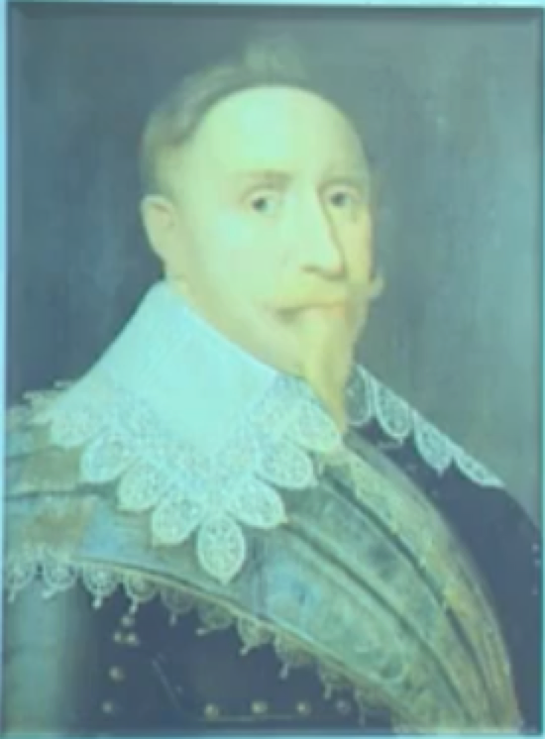

知识点（2）课文背景介绍：**三十年战争**

**Thirty Years' War:** A series of wars in central Europe beginning in 1618 that stemmed from conflict between Protestants and Catholics and political struggles between the Holy Roman Empire and other powers. It ended with the Peace of Westphalia (1648).

知识点（3）

**be at the height of one’s success / fame / powers** etc**英文解释：**to be more successful, famous etc than at any other time 在某人最…的时候

* The Beatles **were at the height of their fame**.

知识点（4）**【词汇】**

**dictate** v. **英文解释：**to give orders, or state sth. exactly, with total authority 指定

* The UN will **dictate** the terms of troop withdrawal from the region.

知识点（5）**【词汇】**

**measurement** n. [C, usually pl.] **英文解释：**the length, height etc of something 尺寸

* Take **measurements** of the room before you buy any new furniture.

知识点（6）**【词汇】**

**armament** [U] **英文解释：**process of equipping military forces for war 武装

# Triple gun-decks mounted 64 bronze cannon.

知识点（1）**【词汇】**

**mount** v. **英文解释：**to fix sth. into position on sth., so that you can use it, look at it or study it 将某物固定住（以备使用、展示或研究）

**mount sth. (on / onto / in sth.)** 将某物固定住…

* The specimens **were mounted on** slides.
* The diamond **is mounted in** gold.
* a wall-**mounted** electric fan

知识点（2）**【词汇】**

**bronze** 青铜

**brass** 黄铜

**copper** 铜

知识点（3）**【词汇】**

**cannon** n. (复数cannon 或cannons) **英文解释：**a large heavy powerful gun that was used in the past to fire heavy metal balls（发射实心金属炮弹的旧式）大炮

# She was intended to play a leading role in the growing might of Sweden.

知识点（1）**【词汇】**

**intended** adj. **英文解释：**planned or designed for a particular purpose or person 为了……而计划或设计的

**be intended for … / to do …** 为了…而计划或设计的

* The book **is intended for** children.
* The age limit **is intended to** guarantee that not only past work is rewarded. The Fields Medal **is** also **intended to** encourage the winners to make further contributions.

# （第三段）

# As she was prepared for her maiden voyage on August 10th, 1628, Stockholm was in a ferment.

**语法分析：**

As she was prepared of her maiden voyage on August 10, 1628（时间状语）（时间状语从句）, Stockholm was in a ferment.

知识点（1）**【词汇】**

**ferment** n. [U, sing.] **英文解释：**a situation of great excitement or trouble in a country, especially caused by political change 激动不宁，动荡不安

* The whole country has been **in** a state of political **ferment** for some months.

# From the Skeppsbron and surrounding islands the people watched this thing of beauty begin to spread her sails and catch the wind.

**语法分析：**

From the Skeppsbron and surrounding islands（地点状语） the people watched this thing of beauty begin to spread her sails and catch the wind（非谓语动词做后置定语）.

知识点（1）

**thing of beauty**

= **beautiful thing**

知识点（2）

spread sails 杨帆

* A ship **with all of its sails spread** is a gallant sight.
* My heart has **spread its sails** to the idle winds for the shadowy island of Anywhere.

**【相关词组】**表达“帆船”：

**hoist / lower the sails** 升/降帆

**set sail** 启航

* The following week the 'Queen Elizabeth' **set sail for** New York.
* Mrs. Healy moved away like a ship **in full sail** (**= with all its sails spread**).

知识点（3）

**catch the wind** 兜住风

* The sails are torn; they won't **catch the wind**.
* You cannot **catch the wind** in a net.

# They had laboured for three years to produce this floating work of art; she was more richly carved and ornamented than any previous ship.

**语法分析：**

They had laboured *for three years（时间状语）* to produce this floating work of art（目的状语）; she was more richly carved and ornamented than any previous ship（比较状语）.

知识点（1）**【词汇】**

**labour** / **labor** v. to work hard

* Five generations of his family have **labored** as fishermen.
* Three hours after the explosion, rescue teams were still **laboring** to free those trapped.

知识点（2）

**work of art** n. **含义**1. a painting, statue, etc. 艺术品；（绘画、雕塑等）艺术作品

* A number of priceless **works of art** were stolen from the gallery.

**work of art** n. **含义**2. something that is attractive and skillfully made 令人赏心悦目的东西；精致的物品

* The bride's dress was a **work of art**.

知识点（3）**【词汇】**

**richly** adv. **英文解释：**if something is richly decorated, it is decorated a lot, in a way that is beautiful 富丽堂皇地

* a **richly** carved ceiling
* a table **richly** ornamented with carvings
* a cloak **richly** embroidered with gold thread

# The high stern castle was a riot of carved gods, demons, knights, kings, warriors, mermaids, cherubs; and zoomorphic animal shapes ablaze with red and gold and blue, symbols of courage, power, and cruelty, were portrayed to stir the imaginations of the superstitious sailors of the day.

**语法分析：**

The high stern castle was a riot of carved gods, demons, knights, kings, warriors, mermaids, cherubs; and zoomorphic animal shapes ablaze with red and gold and blue, **symbols of courage, power, and cruelty**（red and gold and blue的同位语）（ablaze with… 后置定语）, were portrayed to stir the imaginations of the superstitious sailors of the day.

知识点（1）

**be a riot of sth.** (fml.) **英文解释：**be full of a collection of a lot of different types of the same thing 充满了，充斥着

* The garden **was a riot of** colour.
* The market **was a riot of** unfamiliar sounds and smells.

知识点（2）**【词汇】**

**ablaze** adj. **含义**1. burning strongly with a lot of flames 熊熊燃烧的

* Within minutes the whole house was **ablaze**.

**ablaze** adj. **含义**2. very bright or colorful 光鲜的，明艳的

**ablaze with …**

* Her yard **was ablaze with** summer flowers.
* The trees were **ablaze with** the colors of autumn.

知识点（3）

**symbol of …** ……的象征、标志

* The dove is a **symbol of** peace.
* The lion is the **symbol of** courage.
* The cross is the **symbol of** Christianity.

知识点（2）**【词汇】**

**portray** v. **英文解释：**to show sb./sth. in a picture; to describe sb./sth. in a piece of writing（以绘画或文字）描绘

* The painting **portrays** the duke's third wife.
* His war poetry vividly **portrays** life in the trenches.

# （第四段）

# Then the cannons of the anchored warships thundered a salute to which the Vasa fired in reply.

**语法分析：**

Then the cannons *of the anchored warships（后置定语）* thundered a salute to which the Vasa fired in reply（定语从句）.

知识点（1）**【词汇】**

**anchor** v. [I, T] 抛锚；下锚

* We **anchored** (our boat) close to the shore.
* Before she had **anchored**, the men from the boats had climbed on board and the decks were soon covered with colourful rugs from Persia, silks from India, copper coffee pots, and beautiful hand-made silver-ware.

知识点（2）**【词汇】**

**salute** n. **含义**1. an official occasion when guns are fired into the air to show respect 鸣礼炮致敬

* Bands played, and there was a 21-gun **salute**.

**fire / thunder a salute** 鸣礼炮致敬

* fire a salute of ten guns
* Then the cannons of the anchored warships **thundered a salute** to which the Vasa **fired (a salute)** in reply.

**salute** n. **含义**2. an act of raising your right hand to your head as a sign of respect, usually done by a soldier to an office敬礼

**give / return a salute** 向某人敬礼/还礼

* The soldier **gave a salut**e and the officer **returned** it.

知识点（3）

**in reply / response to sth.** 作为对…的回应

* I am writing **in reply / response to** your letter of June 12.
* **In response to** renewed pleadings, Bruce stopped.

知识点（4）【课文仿写】

* 造句：哨兵 (sentry) 向我们敬礼，我们挥手 (wave) 还礼。
* The sentry gave us a salute to which we waved in reply.

# As she emerged from her drifting cloud of gun smoke with the water churned to foam beneath her bow, her flags flying, pennants waving, sails filling in the breeze, and the red and gold or her superstructure ablaze with colour, she presented a more majestic spectacle than Stockholmers had ever seen before.

**语法分析：**

As she emerged from her drifting cloud of gun smoke with the water churned to foam beneath her bow（独立主格1，做伴随状语）, her flags flying（独立主格2，做伴随状语）, pennants waving（独立主格3，做伴随状语）, sails filling in the breeze（独立主格4，做伴随状语）, and the red and gold of her superstructure ablaze with colour （独立主格5，做伴随状语）（As... 时间状语从句）, she presented a more majestic spectacle than Stockholmers had ever seen before（比较状语从句）.

知识点（1）**【词汇】**

**drift** v. to move slowly on water or in the air 漂流，飘移

* The boat **drifted** down the river.
* Thick smoke from a forest fire **drifted** across the town.

知识点（2）**【词汇】**

**cloud** n. **英文解释：**a large amount of smoke, dust, steam, etc. in the air 烟云，烟尘

* **cloud** of dust / smoke / gas …
* The hens darted away on all sides, raising a **cloud** of dust.

知识点（3）**【词汇】**

**churn (up)** v. **英文解释：**if water, mud etc churns, or if something churns it, it moves about violently 翻滚，翻腾，汹涌奔腾

* The water **churned** beneath the huge ship.
* The sea was **churned up** by heavy winds.

知识点（4）**【词汇】**

**foam** n. [U] **英文解释：**a mass of very small air bubbles on the surface of a liquid 泡沫

* a glass of beer with a good head of **foam**
* The breaking waves left the beach covered with **foam**.
* The ship's propeller **churned** the waves **to foam**.
* The wind howled and **churned up** the water **into** swirling **foam**.

知识点（5）**【词汇】**

**pennant** n. **英文解释：**long narrow flag tapering to a point, used on a ship for signaling or as identification （船上用作信号或识别标志的）长三角旗

知识点（6）**【词汇】**

**fill** v. become full 充满

* The hall soon **filled**.
* The sails **filled** with wind.

知识点（7）**【词汇】**

**superstructure** n. **英文解释：**the structural part of a ship above the main deck 甲板上部结构，船楼

# All gun-ports were open and the muzzles peeped wickedly from them.

知识点（1）**【词汇】**

**gunport** / **gun-port** n. 战舰上的炮门，炮眼

知识点（2）**【词汇】**

**muzzle** n. **英文解释：**open end of a firearm, out of which the bullets, etc come 枪

口，炮口

知识点（3）**【词汇】**

**peep** v. **英文解释：**to look at something quickly and secretly, especially through a hole or opening 窥视，窥探

* We caught her **peeping** through the keyhole.

# （第五段）

# As the wind freshened there came a sudden squall and the ship made a strange movement, listing to port.

**语法分析：**

As the wind freshened（时间状语） there *came（特殊there be句型）* a sudden squall and the ship made a strange movement, *listing to port（非谓语动词引导结果状语）*.

知识点（1）**【词汇】**

**freshen** v. **英文解释：** (of the wind) become strong and cool （指风）变得强而凉

* The wind will **freshen** tonight.
* a **freshening** onshore breeze

知识点（2）

**语法**：**非be 动词的存在句型 (existential sentences with verbs other than ‘ be’)**

**there 常与 be 动词之外的不及物动词 (come, go, arrive, follow, rise, exist, appear, remain, live, lie, stand, happen, occur 等等) 构成存在句， 以突出句末的主语。**

* **There came** to his mind her beautiful face.
* **There remains** nothing more to be done.
* **There followed** an uncomfortable silence.
* **There rose** in his imagination visions of a world empire.
* Not long after this, **there occurred** a sudden revolution in public taste.
* Fortunately for me, as I was wondering what to do next, **there appeared** on the horizon a man on horseback, riding in my direction.

知识点（3）

写作：动词名词化

… the ship **made** a strange **movement** …

* He **made** no other **movement**, but stood with his thumbs in his belt.

**discover** …

* make a **discover** of …

**describe** …

* make a **description** of …

**investigate** …

* make an **investigation** of …

**summarize** …

* make a **summary** of …

**analyze** …

* make an **analysis** of …

**contribute to** …

* make **contributions to** …

**emphasize** / **stress** …

* **lay/put + emphasis/stress on …**

**understand** …

* have an understanding of …

**consider** …

* give consideration to …

**object to** …

* **have an objection to** …

知识点（4）**【词汇】**

**list** v. **英文解释：**  (of a ship) lean over to one side（指船）倾侧

* The ship **lists** to port.
* The damaged vessel was **listing** badly.

# The Ordnance officer ordered all the port cannon to be heaved to starboard to counteract the list but the steepening angle of the decks increased.

**语法分析：**

The Ordnance Officer **ordered** all the port cannon ***to*** *be heaved to starboard to counteract the list（目的状语）*, but the steepening angle of the decks increased.

知识点（1）**【词汇】**

**ordnance** n. [U] **英文解释：**large guns with wheels 大炮

**Ordnance** Officer n. 炮长，司炮

知识点（2）

**heave** v. **英文解释：**to push, pull, or lift a heavy object using a lot of effort 用力推、拖拽或提升重物

* Alan **heaved** his suitcase onto his bed.

知识点（3）**【词汇】**

**counteract** v. **英文解释：**to reduce or prevent the bad effect of something, by doing something that has the opposite effect 对抗，抵消

* These exercises aim to **counteract** the effects of stress and tension.

知识点（4）**【词汇】**

**steepen** v. **英文解释：**to become or to make sth. become steeper 使更陡峭

* After a couple of miles, the slope **steepened** considerably.

# Then the sound of rumbling thunder reached the watchers on the shore, as cargo, ballast, ammunition and 400 people went sliding and crashing down to the port side of the steeply listing ship.

**语法分析：**

Then the sound of rumbling thunder reached the watchers on the shore, as cargo, ballast, ammunition and 400 people went sliding and crashing（方式状语） down to the port side of the steeply listing ship（as... 原因状语从句）.

知识点（1）**【词汇】**

**rumble** v. **英文解释：**make a deep heavy continuous sound 发出持续的低沉的声音

* The machine **rumbled** as it started up.
* thunder **rumbling** in the distance
* I'm so hungry my stomach's **rumbling**.

知识点（2）

**写作**：突出句末或句首重点，改变语序

* Then the sound of rumbling thunder reached **the watchers on the shore** …
* Then the watchers on the shore heard **the sound of rumbling thunder**, …
* We heard of **the news** that …
* **The news** came to us that …

知识点（3）**【词汇】**

**cargo** n. [U and C] **英文解释：**the goods that are being carried in a ship or plane（船

或飞机上的）货物

* The captain knew that another attempt would be made later, for the sunken ship he was trying to find had been carrying a precious **cargo** of gold bullion.

知识点（4）**【词汇】**

**ballast** n. [U] **英文解释：**heavy material that is carried by a ship to make it more steady in the water（船中用以保持平稳的）压舱物

知识点（5）**【词汇】**

**ammunition** n. [U] **英文解释：**supply of bullets, bombs, grenades, etc fired from weapons or thrown 弹药

知识点（6）

**go doing** **英文解释：**to move in a particular way 以某种方式移动 （做方式状语）

* The plate **went *crashing***to the floor.
* The train **went *chugging***up the hill.
* She **went *sobbing***up the stairs.
* Chairs and tables **went** ***flying***into the arcade.

# The lower gun-ports were now below water and the inrush sealed the ship's fate.

知识点（1）**【词汇】**

**inrush** n. [C usually singular] **英文解释：**an occasion when sth. such as water or air enters a place quickly（水或空气的）涌入

* an **inrush** of air / water
* The **inrush** of fresh air filled the room.

知识点（2）

**seals ’s fate / seal the fate of sb. 英文解释：** to show or decide that sth. bad will definitely happen to someone 注定了……的厄运，使……在劫难逃

* The discovery of new evidence **sealed** his **fate**.
* The outbreak of war **sealed** the government's **fate**.
* Further floods may have **sealed** the **fate of** the few remaining villages.

# In that first glorious hour, the mighty Vasa, which was intended to rule the Baltic, sank with all flags flying -- in the harbour of her birth.

**语法分析：**

In that first glorious hour（时间状语）, the mighty Vasa, which was intended to rule the Baltic（which... 非限定性定语从句）, sank *with all flags flying（独立主格，做伴随状语）―in the harbour of her birth*.

知识点（1）**【词汇】**

**birth** n. **英文解释：**the time when something new starts to exist（新事物的）诞生

* the **birth of** a nation
* The film **gave birth to** a TV show of the same name.